Easy Bean Tostadas

Ingredients

Kitchen Materials | Supply Table
1 tablespoon vegetable oil  Cutting board  Grater  Turner  Tongs  Custard Cup for Beans  Spoon | Nonstick skillet  Knife  4 corn tortillas  Salt  ½ can refried beans  2 leaves iceberg lettuce, sliced thin  ½ medium tomatoes, chopped  ½ chopped peeled and pitted avocados or guacamole  Grated Monterrey Jack, Cheddar, or crumbled queso fresco  Optional: salsa and sour cream

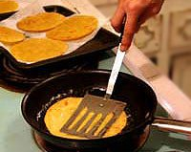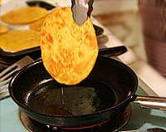
1 Pour a small amount oil into a frying pan so that you have a quarter inch layer of oil (reserve some to put in when you are halfway done frying). Heat the oil on medium (5 on the dial) heat until hot, but not smoking. One at a time, fry the tortillas in the oil. Bubbles should form in the tortilla immediately as you put the tortilla in the oil, otherwise the oil is not hot enough. Fry until golden brown on both sides, cooking about 30 seconds to a minute per side. Use metal tongs or a spatula to push the tortilla down in the oil, and to turn and lift the tortilla out of the pan, draining the excess oil as you do so. (The tortilla should be fairly stiff and crisp. If not, the oil is not hot enough.) Place the tortilla on a paper towel-lined plate, to absorb the excess oil. Sprinkle with a little salt.
Add more oil to the pan as needed, taking care that the oil heats sufficiently before adding a tortilla to the pan.

2. Heat your beans in a GLASS custard cup 20 seconds at a time until warm.

3 To prepare one's tostada, spread a large spoonful of mashed beans over a tostada shell. Sprinkle on cheese and other toppings (sliced lettuce, avocados, salsa, etc.) Don't load the tostada too much or you'll find it difficult to eat. Eat by picking up the tostada with both hands (like a pizza slice).

CLEAN YOUR COOKTOP WITH THE CLEANER ON THE FRONT COUNTER!

