Nutrition Body Assignment
Task 1: With a PARTNER answer the nutrient questions on the attached worksheet. You will need to pick 2 vitamins from the vitamin list and 2 minerals from the mineral list to also answer questions about.
FILL OUT USING THE INTERNET

Nutrient | How does it help our body? | What food is it found in?
Carbohydrates

Protein

Fats

Water

Mineral 1 you selected ______________
Mineral 2 you selected ______________
Vitamin 1 you selected ______________

Vitamin 2 you selected ______________

Task 2: BODY PICTURE WORKSHEET. This is your ROUGH DRAFT!
On the body you are going to represent all 8 nutrients using pictures and words.
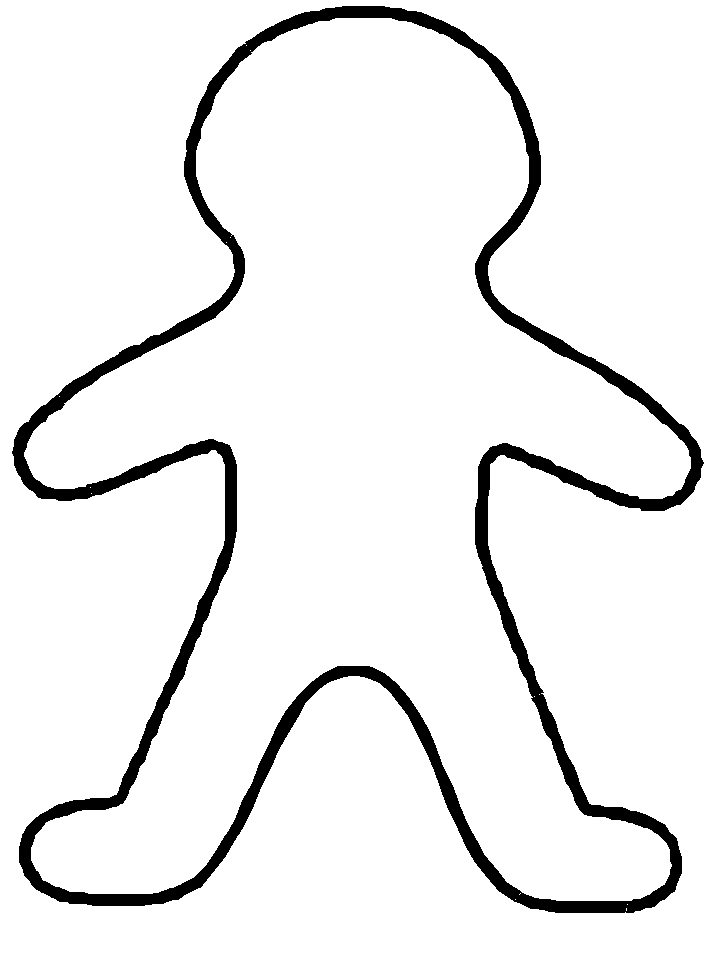
1) Show what the nutrients do or what parts of the body they help.
- Example: Calcium builds strong bones. You might draw a big bone in the leg and write your information about calcium there.
  - Be sure to draw an arrow to each picture, label them, and write what it does! For all 8!!!!

2) For each nutrient you must also include a food source-what foods contain this nutrient? You
will draw and label the food source near your information on that nutrient.
- EXAMPLE- Next to the bone drawing you might have an arrow pointing outside of your body outline to a picture of a cow or a glass of milk.

TASK 3: Get a LARGE piece of butcher roll paper. It needs to be the length of the group member you are tracing!
- Lay the paper on the floor and have your volunteer lay on top of the paper.
- Trace their outline with a pencil and then go over in marker.
- BE CREATIVE- you can pose!

TASK 4: GOOD COPY! Now you will draw your final copy of your nutrient body! These will be hung in the hall and must be COLORED! DECORATE! COLOR! Give your nutrient body clothing and hair!

